School of Informatics & Cybersecurity - Assessment Submission Coversheet

Student Information
Student Number: | B00173541
Student Name: | Sofiia Prymak

Module Information
Module Title: | Database Fundamentals
Module Code: | COMP-H1029

Assessment Information
Assessment Title: | DBF project

Declaration
☐ I confirm that I have read and understood the University’s Academic Integrity Policy.
https://www.tudublin.ie/explore/about-the-university/academic-affairs/academic-quality-assurance-and-enhancement/academic-integrity/
☐ I have completed the TU Dublin AI Driving License theory test.
https://www.tudublin.ie/explore/about-the-university/academic-affairs/lta/lta-resources/artificial-intelligence-driving-license/
☐ I declare that this assessment submission is my own work.
☐ I confirm that I have read and understood the AI traffic light system used as part of this assessment brief and I have adhered to the level of AI usage allowed for this assessment.

Student signature: | Sofiia Prymak
Date: | 25/11/2025

Table of Contents
Task One Database Design 3
Explanation of Each Entity 3
Relationships, cardinalities and rules 3
Conceptual ERD 5
Logical ERD 5
Physical ERD 6
1.7 3RD Normal Form Relational Model 6
Task Two — Create & Populate the Database 6
Insert Statements (DML) 8
Task Three 9
CONCLUSION 15

Task One Database Design
Entities, type, primary key and attributes.
In my database for this hospital project, there will be the following entities, as I demonstrate in my table:
Entity | type | PK | attributes
Department | Strong | departmantID | Departmentname,phoneNumber,address,stuffID
staff | strong | staffID | firstName,lastName,jobTitle, Hiredate, phone,DepartmentID(FK)
patient | strong | patientID | firstName,lastName,dateofbirth,gender,phone,email,address,medicalHistory
treatment | strong | treatmentID | treatmentName, Description, Cost,type, departmentID(FK)
appointment | weak | appointmentID | patientID(FK), staffID(FK), treatmentID(FK), departmentID(FK), appointmentDateTime

Explanation of Each Entity
My project will use five entities, which I will explain in detail below:
- Department: I needed the department to store information about all the medical departments in our hospital, so I am including contacts and hospital managers here
- Stuff: They were needed for information about all hospital stuff, including doctors, nurses, and other staff working at the hospital.
- Patient: was needed to store patients' contact information and medical records at the hospital
- Treatment: I created it to store all medical information about procedures.
- Appointment: and the last one I created for storing information about patient appointments, including, for example, the doctor, treatment, date, time, and department.

Relationships, cardinalities and rules
Relationship | entities | cardinality | participation | rules
worksln | Staff to Department | So many staff:1 department | Staff must belong to department, department may have staff | every staff member works in one department. A department can have many or no staff
providesTreatment | Treatment to department | Many treatment:1 department | Each treatment belongs to a department, Department may provide treatments | treatments are done in one department. departments can provide many treatments
hasAppointment | Appointment to patient | Many appoibtments:1 patient | Appointment must have a patient, Patient can have appointments | Each appointment is for one patient a patient can have many appointments
AssignedDoctor | Appointment to staff | Many appointments:1 staff | Appointment must have a doctor, Staff may have appointments | each appointment is handled by one doctor Doctors can have many appointments
forTreatment | Appointment to treatment | Many appointments:1 treatment | Appointment must have a treatment, Treatment may have appointments | each appointment is for one treatment a treatment can appear in many appointments

Conceptual ERD
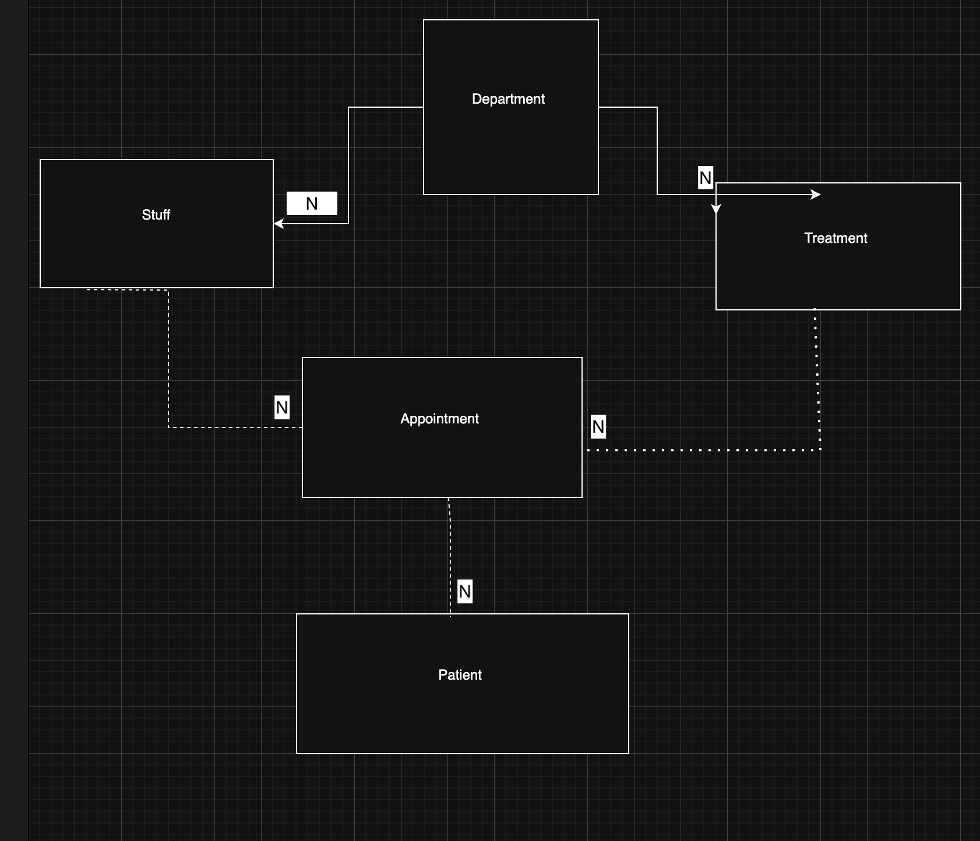

Logical ERD
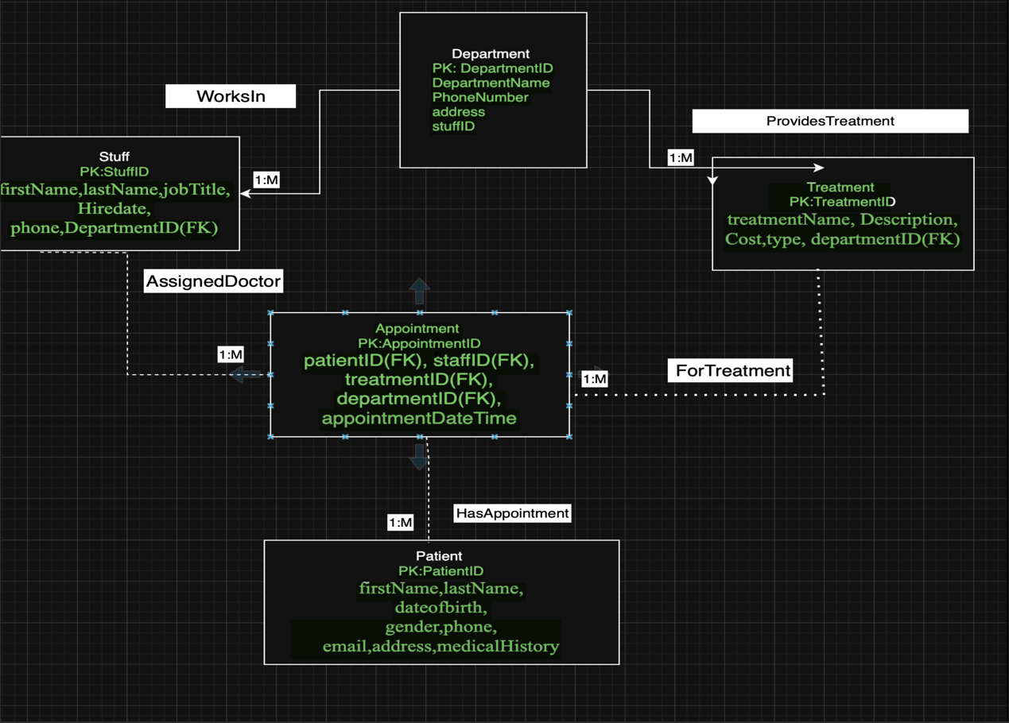

Physical ERD
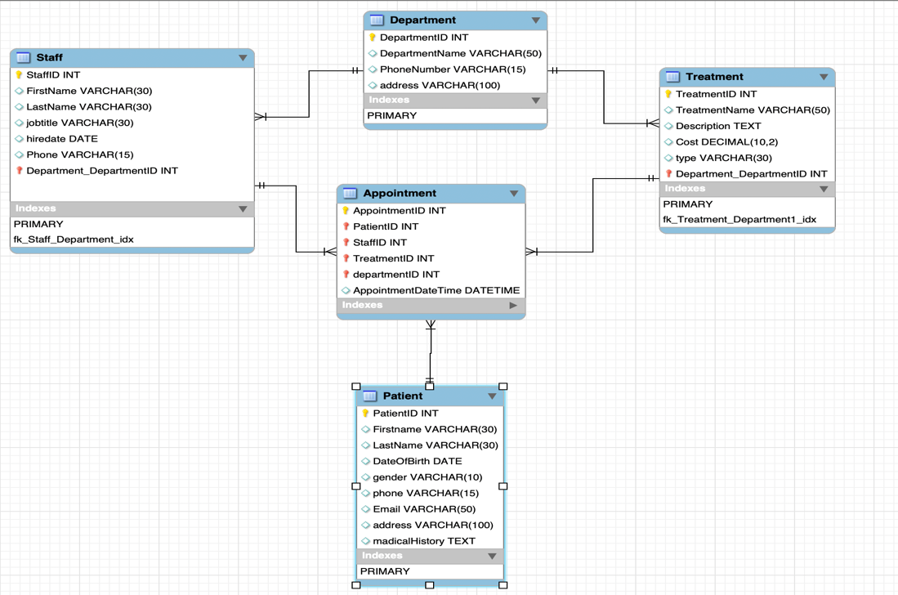

1.7 3RD Normal Form Relational Model
Department(DepartmentID (PK),DepartmentName,PhoneNumber,Address)
Staff(StaffID (PK),FirstName,LastName,JobTitle,HireDate,Phone,DepartmentID (FK)Department.DepartmentID)
Patient(PatientID (PK),FirstName,LastName,DateOfBirth,Gender,Phone,Email,Address,MedicalHistory)
Treatment(TreatmentID (PK),TreatmentName,Description,Cost,Type,DepartmentID (FK)
Appointment(AppointmentID (PK),PatientID (FK) StaffID (FK),TreatmentID(FK), departmentID(FK),AppointmentDateTime)

Task Two — Create & Populate the Database
2.1 Create Table Statements (DDL)
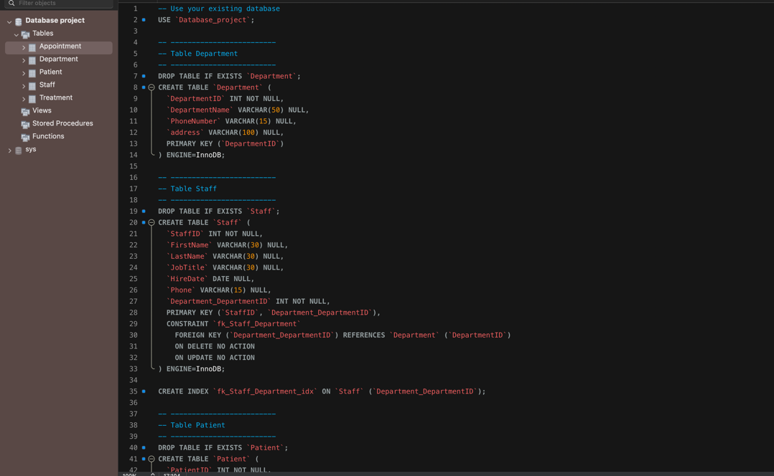
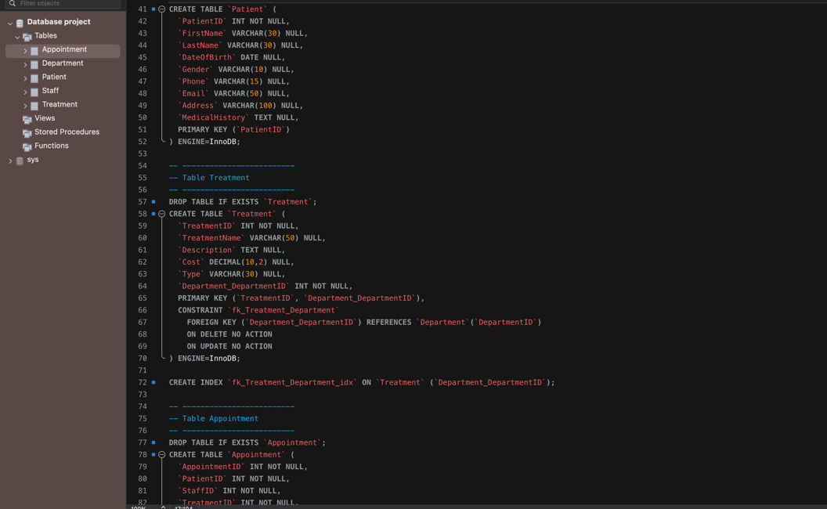
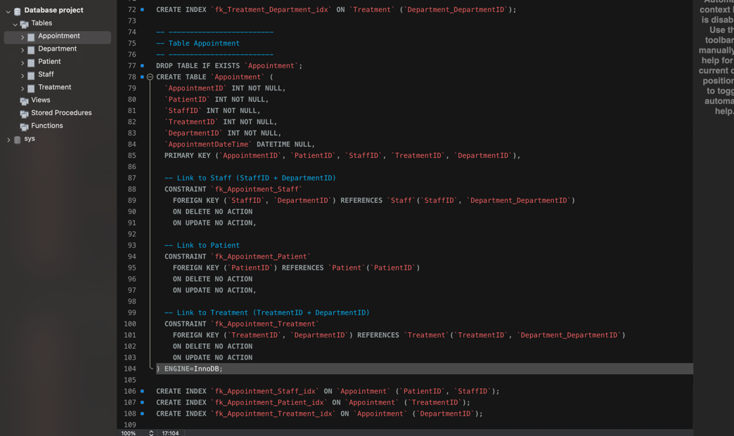

Insert Statements (DML)
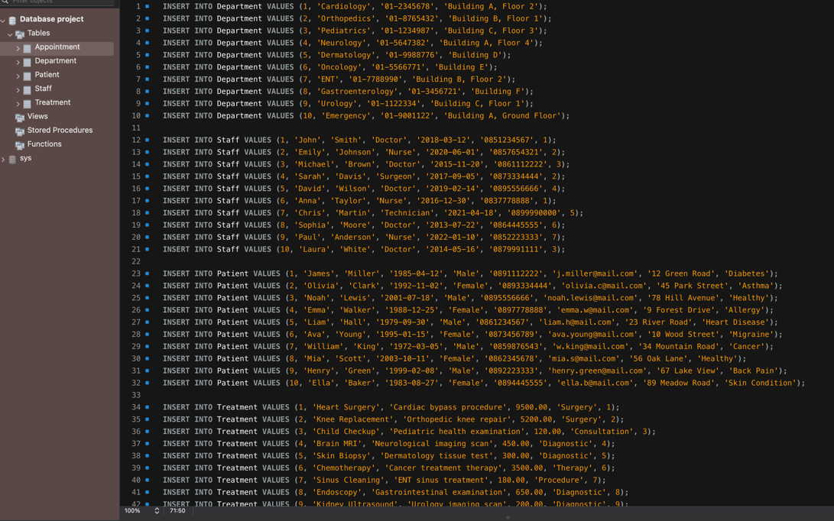
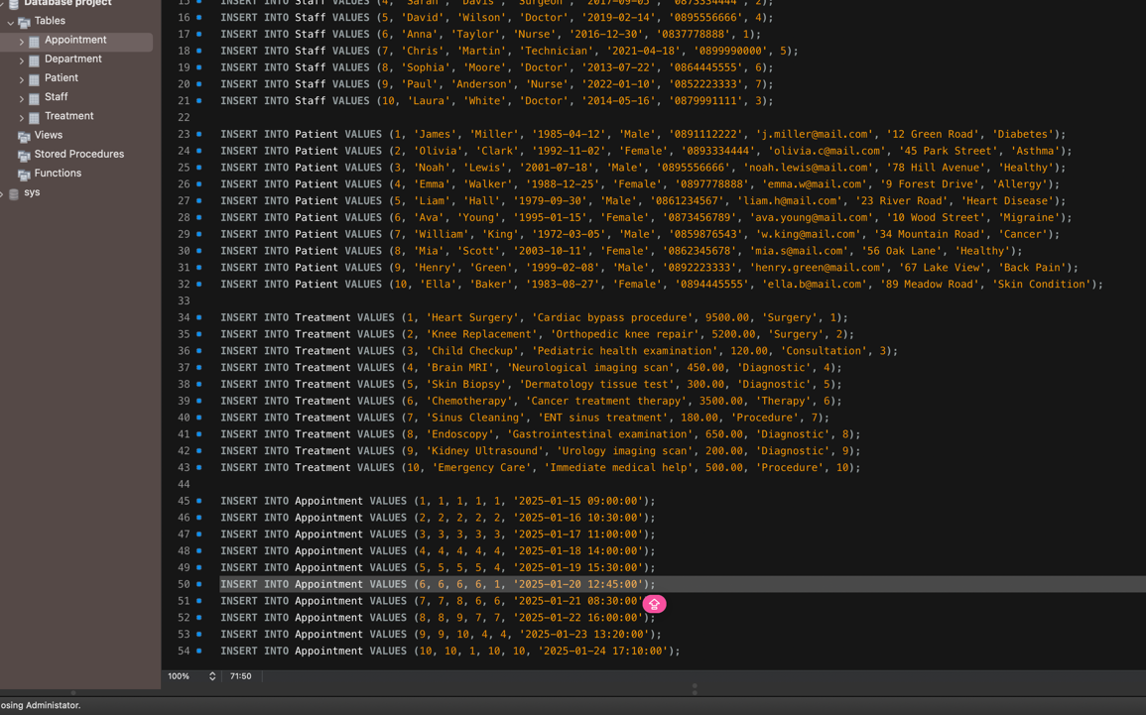

Task Three
- Show details of all medical departments of hospital
In the first task, I opened the department tables and executed a select query that displayed all the tables, and I saw the entire list of medical departments, their telephone numbers, and locations

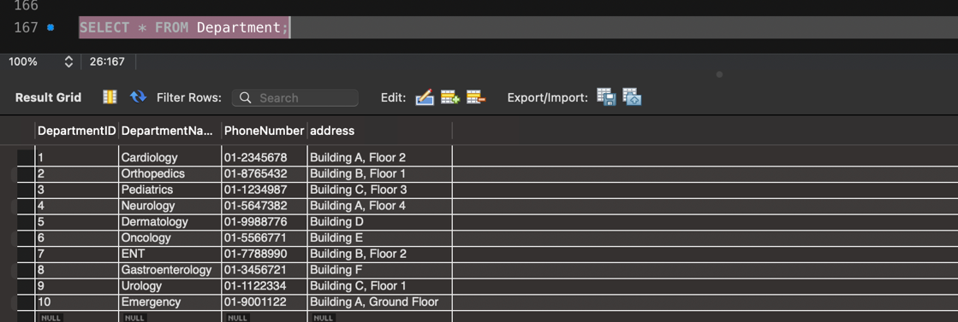

- Find the contact details of patient “John Bob” whose patient ID is 5612

I used select with the patient indicator and their name in this way system showed me John bob

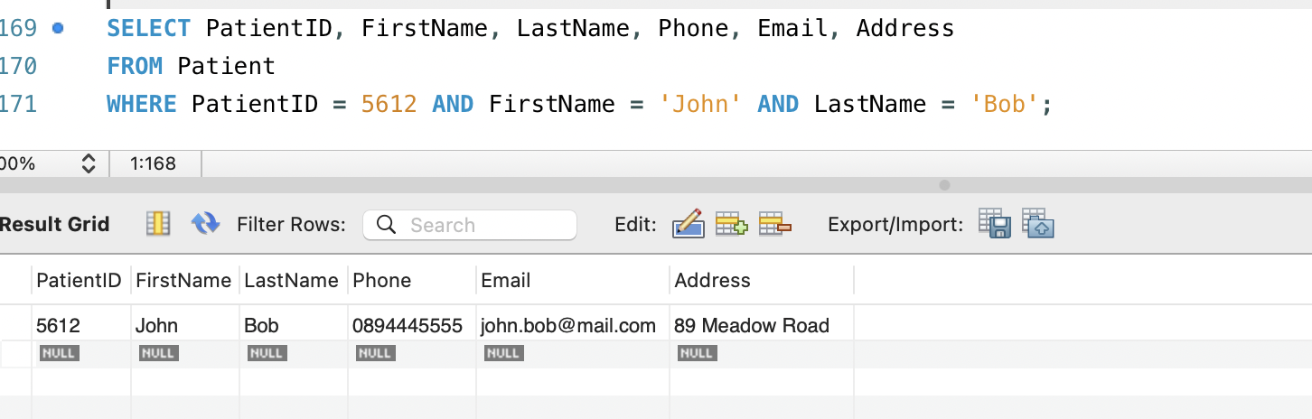
- Update the patient ID number 3456 contact details.

I made update to change phone number and email, address also patient with his or her ID In WHERE, I specified the PatientID column to change only one row
- 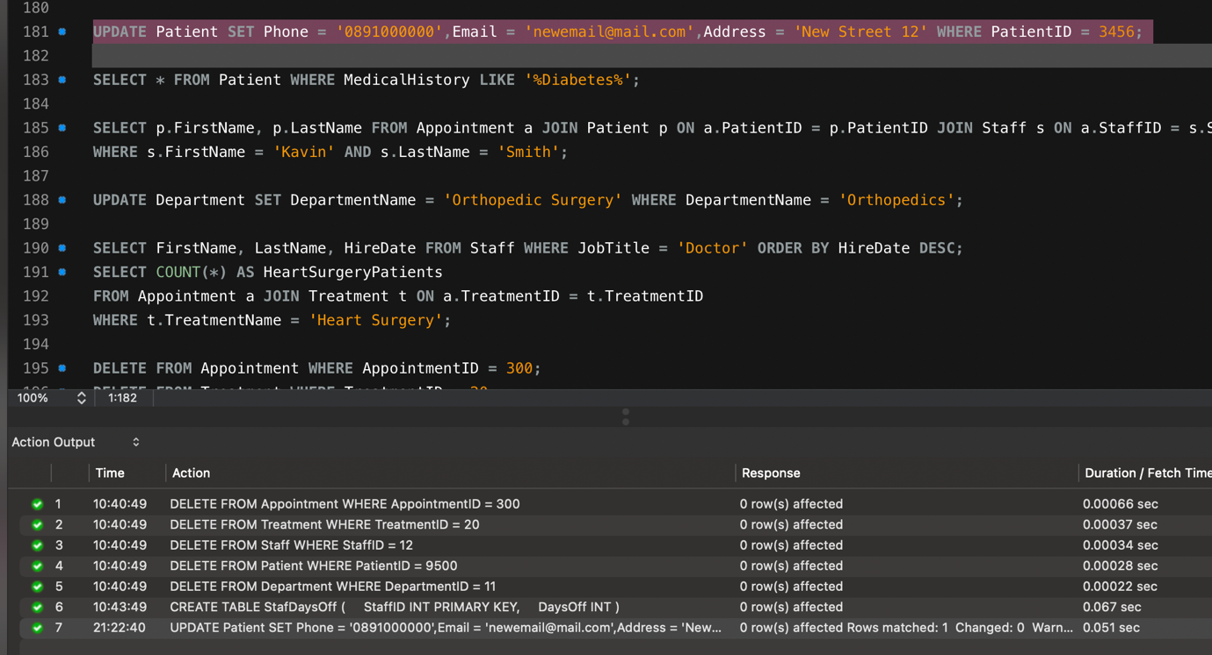

- Schedule a new medical appointment

To add a new table, I used INSERT in the Appointment table. I specified the date, time, patient, employee, and type of treatment, and a new record about the scheduled appointment was created

- Find details of all patients who have Diabetes

To complete this task, I used SELECT with the LIKE condition to find all patients whose medical history mentions diabetes

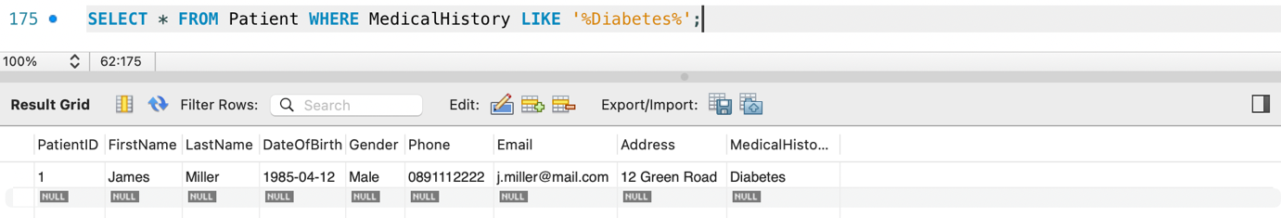
- Display the first name and surname of all patients who are under the care of Dr. Kavin Smith

I found all patients who have appointments with Dr Kavin Smith.To do this, I linked the patient, staff, and appointment tables, and then extracted the names of patients whose attending physician is Kevin Smith

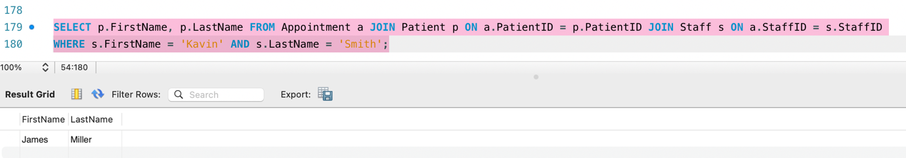

- Change all patients in Orthopedics department to Orthopedic Surgery Department

In this task, the name of the department was changed via update in the department table to a new name such as Orthopaedic Surgery for those rows where Orthopaedics was listed.

- Display the first name, surname, and hire date of all doctors sorted in descending order by hire date.
I selected only those employees with the position of Doctor from the Staff table and displayed their first names, last names, and hire dates. Then I sorted the results.

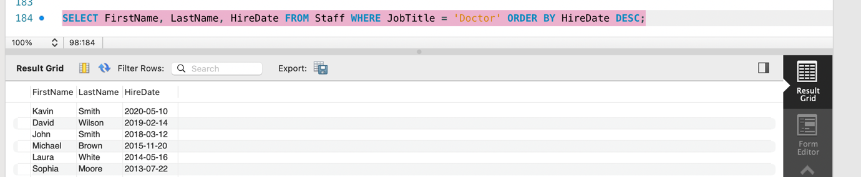
- Count how many patients are undergoing 'heart Surgery' treatment.

In this task, I joined appointment and treatment, and then used count to calculate the total number of people who underwent heart surgery

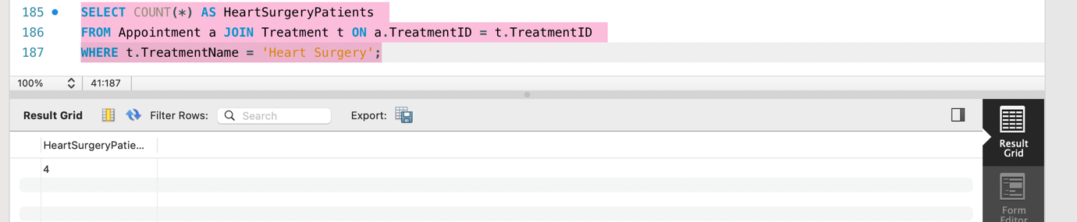
- Add one new record to each table.

In this task, I performed several insert operators for each table, adding one new row to the staff department, patient treatment, and appointment departments
- Delete one record from all tables.

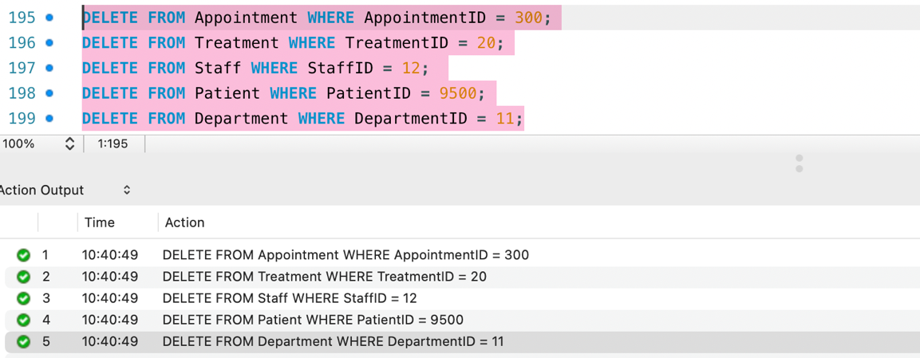
- Find the total number of days off for all staff, order this by least days off

After performing a Select on the StartDaysoff table, I sorted the employees in ascending order by number of days of leave.

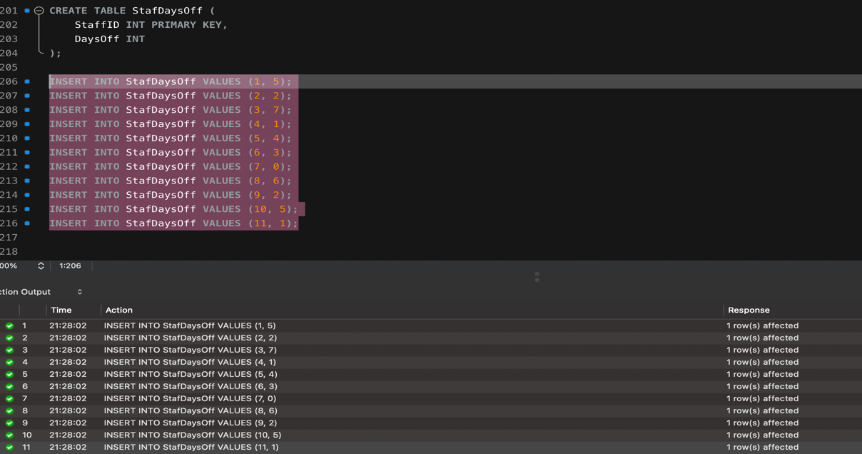

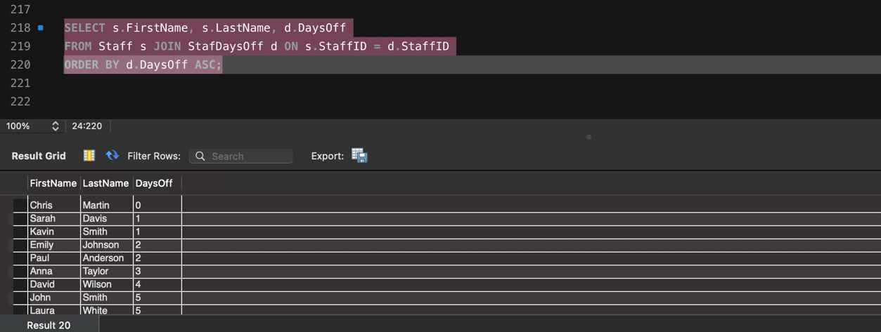
- Change the roll of all staff who have a job title Office worker to Administrator
Here, in my Staff table, I did an UPDATE and replaced Office Worker with Administrator. I used WHERE to change only those whose old position matched.

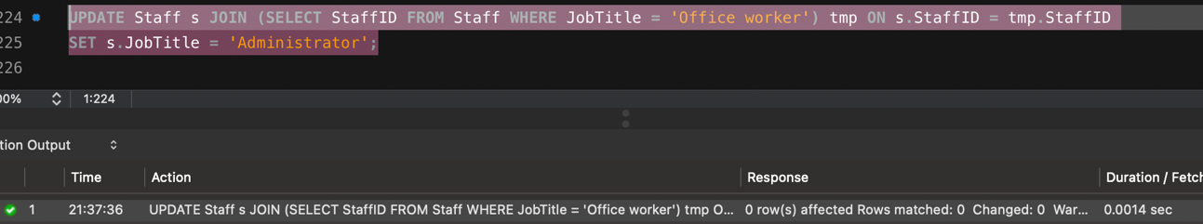

- Set the Orthopedics department phone number to be 01-7654321
In this task, I updated the telephone number in the Department table. Using Update, I set a new telephone number for the department named Orthopaedic Surgery
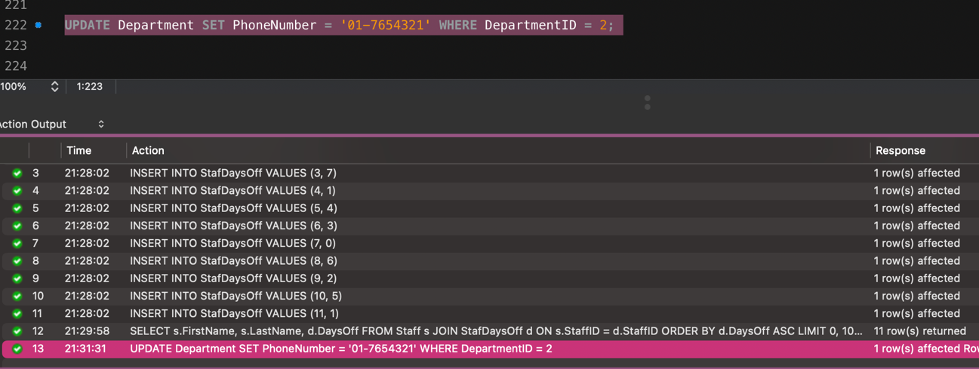
- Set the chief executive officer (CEO) of the hospital to be called Michael Dean

In this task, I changed the first and last name of the employee whose position is listed as CEO in the Staff table. FirstName and Lastname were replaced via Update

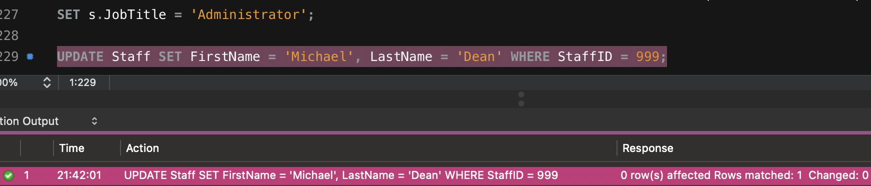
- Show all staff members who have been working there for longer than 3 years
This task was done using SELECT with a condition on the date of hire using the DATEDIFF CURDATE function. So I listed all employees who have been working at the hospital for more than three years

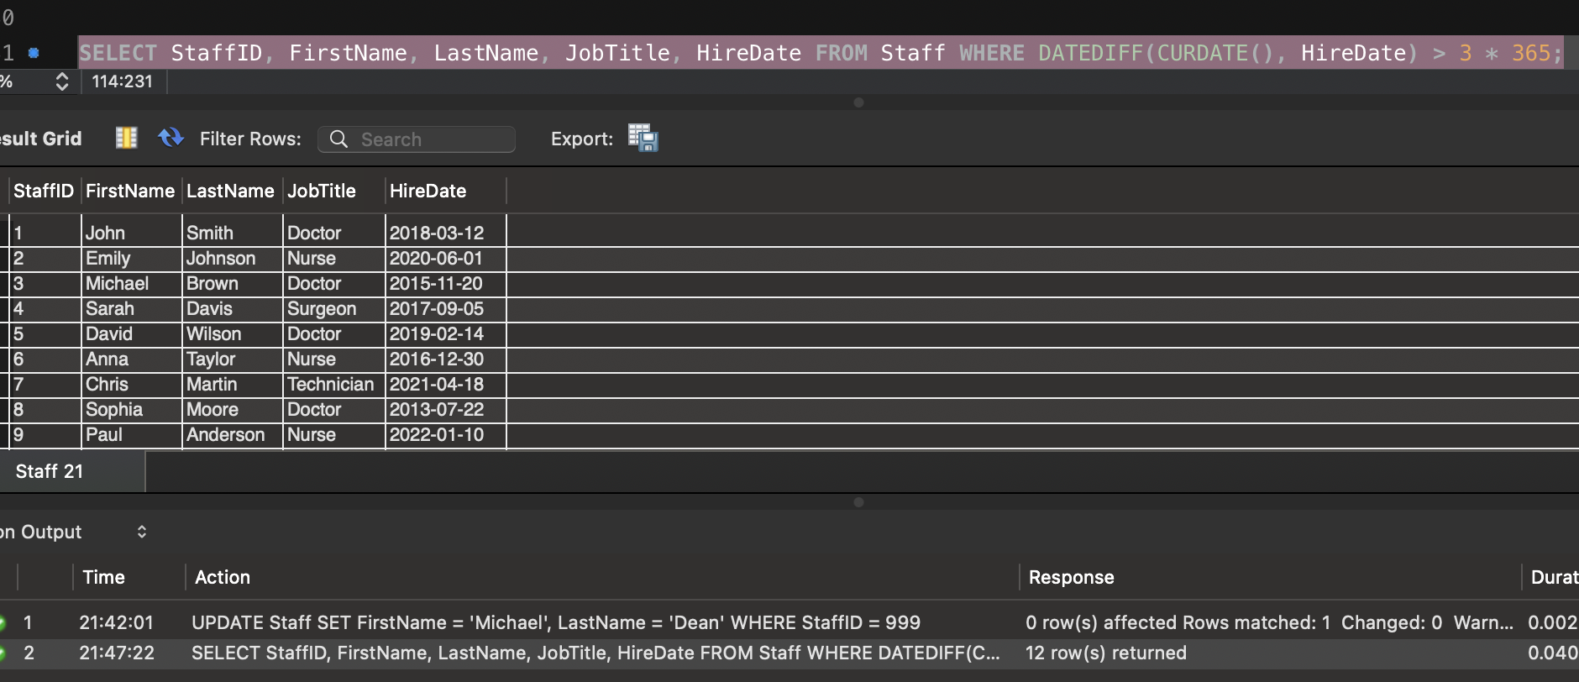
- Show the detail of all patient names, medical history, appointment dates, times, and treatment

For this task, I performed a join between the Patient, Appointment, and Treatment tables. This allowed me to extract all the necessary information in a single query

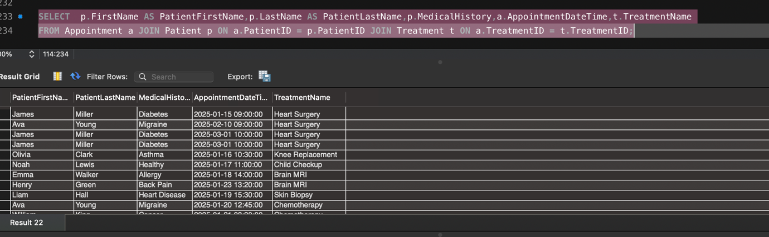
- Identify how many patients have the word road in their address.

Here, I used Select and Count with the condition Like “Road”. This query counted the number of patients whose address contains the word road
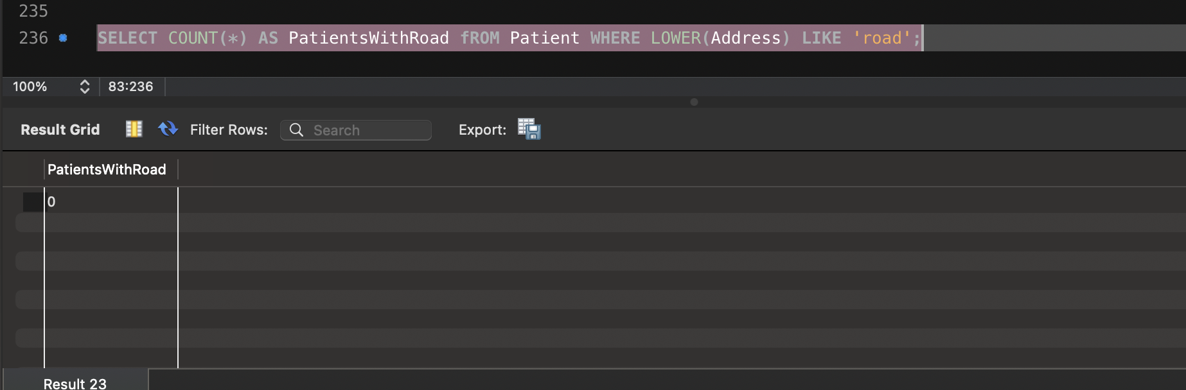
- Create a view that will show the result of a query drawing information from three tables at once.
I created a VIEW that combines Patient, Staff, and Treatment information through Appointment. The view allows you to retrieve a set of data

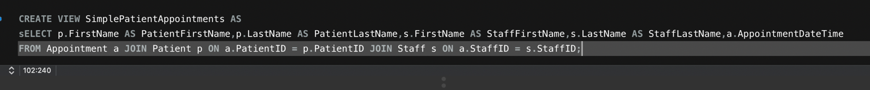
- Drop all information contained in the appointments relation.
I cleared the Appointment table using the DELETE command without a condition. The table remained in place, but all its data was deleted.

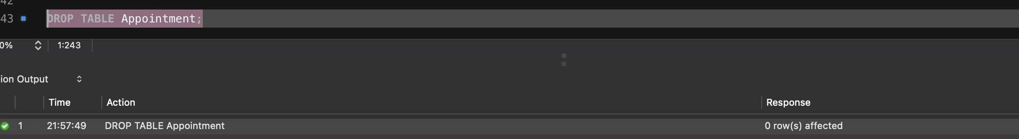

CONCLUSION

In this project, I created a hospital database, then filled it with data and completed all tasks using SQL queries. I learned how to select, update, add and delete data, use Join and create views. This project helped me understand how databases work and how to manage them using MySQL

